Media Contact: Derik Landkammer
derik@nordicwaffles.com
952-567-3034
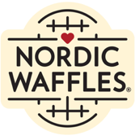
Nordic Waffles Brings the Essence of the Perfect Backyard Cookout to the
2023 Minnesota State Fair
The Waffle Queen Stine Aasland returns with a classic backyard cookout with a touch of Nordic Inspiration
Shakopee, MN —Minnesota State Fair favorite, Nordic Waffles, is thrilled to be named to the State Fair’s New Food List with a delectable waffle sandwich, the “Bacon – Wrapped Waffle Dog”, and a mouthwatering beverage, the “Kind of a Big Dill Lemonade”. Find photo assets here.
The Bacon-Wrapped Waffle Dog:
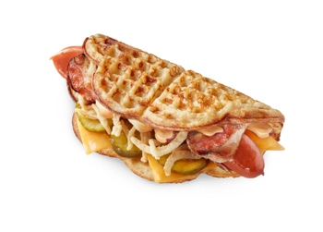
Nordic Waffles delights with Kramarczuk’s Sausage Company’s old fashioned hot dog that is wrapped in bacon, served on a Nordic Waffle with cheddar cheese, pickle slices, crispy onions, and then drizzled with burger sauce.
Kind of a Big Dill Pickle Lemonade:
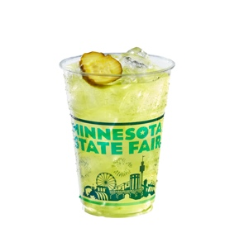
Nothing says State Fair better than pickles and lemonade. Exclusively for Nordic Waffles, Urban Growler Brewing Company, brewed up a non-alcoholic, refreshing lemonade with tangy dill pickling spices, garnished with a crunchy pickle slice.
To celebrate Nordic Waffles 5th Anniversary of the Minnesota State Fair, we’re bringing back fan favorite from the 2019 New Foods List: Pebbles & Bam Bam Waffle! This sweet waffle is made with Reece’s chocolate peanut butter cups and a fruity cereal explosion of crunch.
Nordic Waffles is located in the West End Market along West Dan Patch Ave. near Liggett St., The Nordic-inspired cabin will serve fans from 7:00 a.m. to 9:00 p.m., Aug. 24 to Labor Day, Sept 4.

##Nordic Waffles launched in Minneapolis in 2016. For the next two years, the freshly-made waffle concept expanded into coffee shops, convenience stores and amusement parks. Debuting at the Minnesota State Fair in 2018, Nordic Waffles served more than 42,000 waffles in just 12 days. The brand continued to grow with foodservice partners in regional states and a food hall restaurant locally in 2019. The business shifted gears in 2020 and launched it’s frozen food line. With the continued success of frozen waffle sandwiches in grocery, foodservice, and convenience, Nordic Waffles is now available in more than 1300+ stores across 15 states and during the Minnesota State Fair.
##Urban Growler® Brewing Company was established in 2014 by Master Brewer Deb Loch and co-head honcho Jill Pavlak, creating the first woman-owned microbrewery in Minnesota. Deb & Jill combined their complementary skills and passions to create great brews, food, and space for everyone to enjoy. Urban Growler Brewing company is an established brewery and taproom, and you will find their brews in local retail shops. Their mission is to bring together people through their beverages.
##Kramarczuk Sausage Co. has represented the quality and taste of Eastern European foods in Minneapolis and beyond for more than 60 years. More than a sausage company, Kramarczuk’s is also a bakery, restaurant, and deli. Founded by Ukrainian immigrants Wasyl and Anna Kramarczuk in 1954, Kramarczuk’s preserves traditional methods of preparation using fresh ingredients in everything from Polish sausage to pierogi and cabbage rolls. Kramarczuk’s was named an ‘American Classic’ by the James Beard Foundation in 2013 and is considered a Minneapolis landmark.

Media Contact: Derik Landkammer
Email: derik@nordicwaffles.com
Cell: 952-567-3034

